2 Literature Survey
2.1 Support Vector Machines (SVM)
Support Vector Machines (SVMs) were one of the first machine-learning techniques used to classify ASD using resting‑state fMRI. In a standard pipeline, whole‑brain interregional functional connectivity matrices are calculated (e.g. based on AAL or CC200 parcellations), and Boruta is run to identify the most discriminant connections. Radial‑basis‑function (RBF)‑kernel SVM trained on them has reported a maximum of 92.9 % accuracy under leave‑one‑out cross‑validation. Interestingly, the default mode network (DMN), posterior cingulate cortex (PCC), and ventrolateral prefrontal cortex (vlPFC) are found to be the most informative regions of interest (ROIs) for separating ASD from controls.

2.2 Random Forest (RF)
Random Forests take advantage of ensemble decision trees to cope with the high dimensionality and heterogeneity of functional‑connectivity features. In a given study, RF classification accuracy was very sensitive to sample homogeneity—models based on more homogeneous subgroups (e.g. males with severe symptoms) performed better than those on mixed groups. To address multi‑site variability in large consortia like ABIDE, ComBat harmonization is usually implemented on the connectivity features prior to RF training, leading to more consistent ASD/typical‑control discrimination across acquisition sites.

2.3 Multi‑Layer Perceptron (MLP)
Multilayer Perceptrons (MLPs) learn non‑linear associations in connectivity profiles using cascaded feedforward layers with non‑linear activations. Sophisticated frameworks enhance MLPs with adaptive learning rates and strict feature‑selection techniques (e.g. chi‑square, information gain) to extract the most pertinent connections from ~6,000–20,000‑dimensional feature spaces. Hybrid pipelines also combine MLPs with classical classifiers (KNN, SVM, RF, LDA) or use transfer learning from pre‑trained CNNs (e.g. VGG16) to augment representations. Bio‑inspired optimizations like Zealous Particle Swarm Optimization (ZPSO‑RMLPNN) refine network weights to increase stability, although basic MLPs without any of these optimizations generally reach only 55–65 % accuracy .

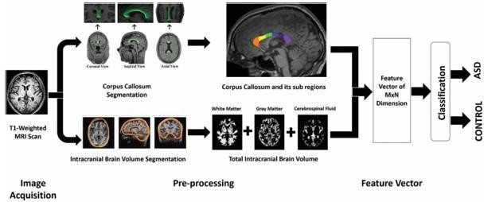
Fig 2.1: Overview of Proposed Framework

2.4 Autoencoders
Denoising autoencoders yield strong unsupervised pre-training to acquire small, noise-robust embeddings of high-dimensional connectivity data. Two-stage denoising progressively reduces ~19,900-dimensional vectors (derived from 200×200 FC matrices) to 1,000 dimensions with 20 % input corruption, then to 600 dimensions with 30 % corruption. The encoder weights pretrain an MLP classifier, reducing overfitting and the curse of dimensionality to enhance ASD/TC separation

2.5 Convolutional Neural Networks (CNN)
CNNs process functional‑connectivity matrices as "images" leveraging spatial locality through convolutional filters. Light‑weight 1D‑CNNs on the ABIDE‑I dataset perform ASD diagnosis with minimal computational cost, and hybrid models combine deep features extracted from pre‑trained networks (VGG16, ResNet101, MobileNet) with classifiers (e.g. XGBoost or SVM). CNN weights have recently been quantized and federated‑learning environments have been combined to execute models on edge devices (e.g. Raspberry Pi), trading off accuracy (up to ~98 %) with privacy and efficience.
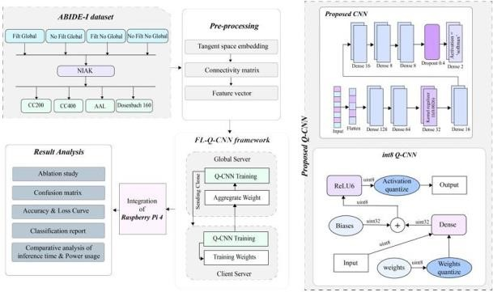
Fig 2.2: Methodology proposed

2.6 Graph Neural Networks (GNN)
Graph Neural Networks naturally represent the brain as a graph of ROIs or, at the population level, subjects as nodes. Multi‑atlas GCN architectures (e.g. MAGE) combine features from several parcellations, perform recursive feature elimination, and utilize a ridge classifier to obtain ~75.9 % accuracy. DeepGCN architectures integrate phenotypic metadata (gender, site) into multi‑graph fusion, with up to 91.6 % accuracy. Graph Attention Networks (GATs) also extend interpretability through learning ROI importance via attention-pooling layers, although computational requirements continue to be a hurdle for large-scale deployments.
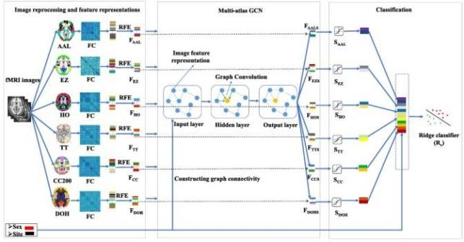
Fig 2.3: MAGE framework

